Evaluating the potential of the unexploited South African Cape sea urchin, *Parechinus angulosus*, for the seafood market.

********

Aimee Cloete

Supervisors:

Prof John J. Bolton (Emeritus Professor UCT)

Dr Marissa Brink-Hull (UCT Postdoctoral Research Fellow)

Dr Brett M. Macey (DFFE, Hon. Research Associate UCT)

Minor Dissertation submitted in partial fulfilment of the requirements for the degree of Master of Science in Applied Ocean Science

University of Cape Town, Department of Biological Sciences

Rondebosch, Cape Town, South Africa 7701

# **Declaration**

I declare that this project is my own, unaided work and has not been previously submitted, in whole or in part, for the award of any degree. Where use has been made of the research of others, it has been duly acknowledged in the text. This project is carried out in the Department of Biological Sciences under the supervision of Dr Marissa Brink-Hull, Dr Brett Macey and Professor John Bolton.

________________________

Aimee Cloete

Department of Biological Sciences, University of Cape Town

# **Acknowledgements**

I would like to acknowledge the All-Atlantic Ocean Sustainable, Profitable and Resilient Aquaculture (ASTRAL) project, which received funding from the EU Horizon 2020 Research & Innovation Programme under Grant Agreement No. 863034, for providing financial support for this project. I would like to thank Dr Marissa Brink-Hull, Dr Brett Macey and Professor John Bolton for the provision of samples and supervision throughout the project. A special thanks to the Department of Forestry, Fisheries and the Environment (DFFE) and all the staff at the DFFE Marine Research Aquarium in Sea Point (Cape Town) for the provision of space and equipment to conduct these trials and provision of support throughout the study. This project received ethics approval from the Aquaculture Animal Ethics Committee (AAEC) in the Fisheries Branch of the DFFE under project approval No 20210224_su_03_Macey.

(acknowledgement of family, friends etc who have assisted..)

# **Abstract**

(will start on this after discussion is complete)

Wild *Parechinus angulosus* were collected in the intertidal and shallow subtidal on a rocky shore in front of the DFFE Marine Research Aquarium in Sea Point, Cape Town (33° 55' 6.492'' S, 18° 22' 52.572'' E).

# **Contents**

**Declaration** 1

**Acknowledgements** 2

**Abstract** 3

**Contents** 4

**List of figures and tables** 6

Figures 6

Tables 6

**List of acronyms** 7

**1.** **Introduction** 8

*1.1.* *Parechinus angulosus* 8

1.2. Sea urchins in the edible market 9

1.3. Diversification of the aquaculture industry 10

1.4. The aquaculture potential of *Parechinus angulosus* 10

1.5. Research aim and objectives 13

**2.** **Literature review** 14

2.1. An overview of the seafood industry 14

2.2. Aquaculture’s contribution to seafood supply 15

4.1. Echinoculture research and practices 16

4.2. Challenges and considerations 17

4.3. Project expectations 17

**5.** **Materials and methods** 17

5.1. Ethics statement 17

5.2. Sea urchin collection 17

5.3. Experimental setup 18

5.4. Data collection 20

*5.4.1.* *Somatic growth and feed conversion ratio* 20

*5.4.2.* *Gonad quantity, quality and development* 21

5.5. Statistical Analyses 24

**6.** **Results** 24

6.1. Survival 25

6.2. Somatic growth 26

6.3. Gonad quantity and quality 28

**1.** **Discussion** 30

**2.** **Conclusion** 30

**3.** **References** 30

# **List of figures and tables**

## Figures

Figure 1: Map of the global occurrence of sea urchin barrens documented throughout the range of kelp (adapted from Filbee-Dexter & Scheibling. 2014).

Figure 1: World capture fisheries and aquaculture production (FAO,2022)

Figure 2: Image of juvenile abalone (Haliotis midae) sheltering beneath Cape sea urchins (Parechinus angulosus) in Simon’s Town, Cape Town, South Africa (Peter Southwood, 2005).

## Tables

Table 1. Tank treatment allocation (F: formulated feed, M: mixed diet, U: ulva, K: kelp). Shaded tanks receive heated water, unshaded tanks receive water at ambient temperature.

# **List of acronyms**

ASTRAL All Atlantic Ocean Sustainable, Profitable and Resilient Aquaculture

AAEC Aquaculture Animal Ethics Committee

CIE International Commission on Illumination

DEFF Department of Environment, Forestry and Fisheries

DOM Dissolved Organic Matter

GSI Gonadal Somatic Index

IMTA Integrated Multi-Trophic Aquaculture

ISA

MRA Marine Research Aquarium

POM Particulate Organic Matter

SA South Africa

SGR Specific Growth Rate

# **Introduction**

## *Parechinus angulosus*

The Cape sea urchin, *Parechinus angulosus*, is endemic to southern Africa and belongs to the Parechinidae family. It is widely distributed from Lüderitz, Namibia to Umhlali, Kwa-Zulu Natal, South Africa (SA) with dense concentrations around the Cape Peninsula (Fricke, 1980). The Cape Peninsula is a region with a strong seawater temperature gradient (~12oC - 17 oC) (Muller et al., 2012; Smit et al., 2013), due to the overlap of the cool Benguela (SA west coast) and warm Agulhas (SA south coast) provinces, and the co-occurrence of species from both marine provinces results in a high species diversity (Leliaert et al., 2000). The region of overlap, referred to as the ‘Western Overlap’ in previous literature, is characterized by kelp beds created by *Ecklonia maxima* (to depths of 8m) and *Laminaria pallida* (predominantly 8-14m and up to 20m depths) wherever there are rocky substrata in the shallow subtidal (Leliaert et al., 2000). The distribution of the Cape urchin is closely associated with the southern African kelp which characterize its habitat. They are prey, although not preferentially, for rock lobsters, *Jasus lalandii* (Van Zyl et al., 2003). The Cape urchin is an important grazer in the southern African kelp bed ecosystem (Greenwood, 1980) where they can feed opportunistically on marine invertebrates and biofilm but primarily feed on macroalgae (Freeman, 2006; Loiderios & Gracía, 2006; Russell et al., 2018; Saucede et al., 2006; Ma et al., 2021), primarily *Ecklonia maxima* (Fricke, 1979).

In contrast to urchins from kelp bed ecosystems in other regions, e.g. *Stronglyocentrotus spp,* the Cape urchin does not sever kelp stipes or form feeding fronts which decimate kelp populations to the point of a regime shift from an algal-dominated ecosystem to an urchin-dominated alternative stable state known as an “urchin barren”(Anderson et al., 1997). Urchin barrens have much lower primary productivity and habitat structural complexity, threatening the health of kelp bed ecosystems (Filbee-Dexter & Scheibling, 2014). The Cape urchin regulates kelp density by grazing on the young sporophytes and kelp debris (Fricke, 1979). Although Cape urchins can climb up and actively graze on the kelp stipes under calm conditions (Fricke, 1979; Morris & Blamey, 2018) this behavior is uncommon due to the generally turbulent sea conditions which produce kelp detritus and provide an ample supply of organic matter for the urchins which reduces the likelihood of active grazing (Fricke, 1979). Although sea urchins have a reputation for destruction in some regions, they are keystone species in the structuring of kelp forest communities (Estes & Palmisano, 1974; Scheibling et al., 1999; Ma et al., 2021).

Sea urchins are a key trophic intermediate in kelp bed ecosystems, through shredding, sloppy feeding and egestion of kelp litter they make kelp detritus more accessible to benthic consumers which are important resources for fish and other predators (Yorke et al., 2019). By grazing on young sporophytes, they also control the rate of kelp settlement (Branch, 2013), increasing the available surface area for other species within the kelp bed ecosystem. Thus, *P. angulosus*, influences the habitat structure and transfer of energy for a guild of consumers with the kelp bed ecosystem. (reference). The disappearance of sea urchins would rapidly increase macroalgae recruitment, decreasing the available surface area for benthic fauna. In addition, without the sea urchin trophic linkage the macroalgae debris would be inaccessible to detritovores, increasing competition for resources and impacting the diversity and trophic structure of the ecosystem. *Parechinus angulosus* maintains the balance and productivity of kelp bed ecosystems in South Africa, their ecological significance is clear. However, their economic and cultural significance requires further study.

## The sea urchin market

Scite AI:

Sea urchins are prized for their gonads (roe) which is a prized delicacy in Asia, Europe (France, Italy & Spain), South America (Chile), North America and the Mediterranean (Stefánsson et al., 2017). (how are they used? Talk about the sushi market. The roe, known as 'uni' in sushi restaurants, is a valuable product derived from sea urchins and is highly sought after in international sushi markets (Teck et al., 2018).). The market is mostly traditional, dominated by Japan which accounts for ~90% of the world demand (Stefánsson et al., 2017). Japan was the largest global harvester until 1987, since then Japanese harvests declined significantly due to overfishing and to meet the increasing demand Japan became dependent on imports (Sonu, 2017). (*who are the biggest harvesters now?) Global landings peaked at ~120 000 tonnes in 1995 (FAO, 2016; Stefánsson et al., 2017) and as demand increased, stocks declined rapidly. why did stocks decline (evidence?) (value of the industry?)

Domestic markets exist in many sea urchin harvesting countries (e.g., Chile, New Zealand and the Philippines). In Mediterranean countries, sea urchin is a basic ingredient for several dishes due to the delicacy of its gonads (roe), and demand is constantly increasing.

What species dominate the market? What determines their value? Is there room for new entrants to the market?

Six species of sea urchin are commercially harvested in Japan.

The market is dominated by only a handful of species, including Green (*Strongylocentrotus pulcheriius*), red (*Strongylocentrotus franciscanus*), and purple sea urchins (*Strongylocentrotus intermedius*) are the species of highest demand (Stefánsson et al., 2017).

- Do they have other uses, besides for human consumption?

In addition to their culinary value, sea urchins are commercially exploited for their gonads, which are used for quality roe production, naphthoquinone pigments, and drug discovery (Rubilar & Cardozo, 2021). Furthermore, sea urchins are used as a feed supplement or total replacement for a commercial shrimp diet, and their feces have been evaluated as a food source for small sea cucumbers in integrated multi-trophic aquaculture systems (Jensen et al., 2018; Yu et al., 2023).

## Research rationale

Parechinus & Parechinus/abalone potential

The high value abalone species, *Haliotis midae* and the Cape sea urchin, *Parechinus angulosus,* have a similar preferred temperature range (12 – 20 °C) (Fricke 1980; Britz et al. 1997; Day and Branch 2002a) and commonly occur together in nature, particularly during the juvenile stages of the abalone life cycle (Day and Branch 2000, 2002a).

Laboratory experiments by Day & Branch (2002a) showed that juvenile abalone prefer to shelter beneath urchins rather than under rocks and crevices. One of the reasons for this preference is that there is insufficient microalgae growth under rocks and crevices to meet the dietary requirements of juvenile abalone (Day & Branch, 2002a) and therefore, the juvenile abalone need to leave their shelter and expose themselves to graze. Juvenile abalone that shelter beneath urchins can reduce or eliminate their exposure to predators such as octopus, rock lobster and predatory fish while grazing (Nepgen, 1982; Smith, 1999; Mayfield et al., 2000). Additionally, the distribution of urchins is wider, more uniform, and more likely to be within range of resources than the physical shelters provided by rocks and crevices (Day & Branch, 2002b) and therefore, sheltering beneath urchins increases the juvenile abalone’s distribution and access to resources.

Previous work done for my honours research project (2022), by the same research group, studied the impacts of urchin waste products on abalone growth and found that supplementing hatchery-reared juvenile abalone diets with Cape sea urchin faecal matter enhanced the growth rates of juvenile abalone. Considering the co-habitation of sea urchins and abalone in natural environments, as well as the potential symbiotic relationships that exist between them, they could be co-cultured as a method of improving animal health through the trophic transfer of microbial communities and as a method to improve the sustainability of the South African abalone industry.

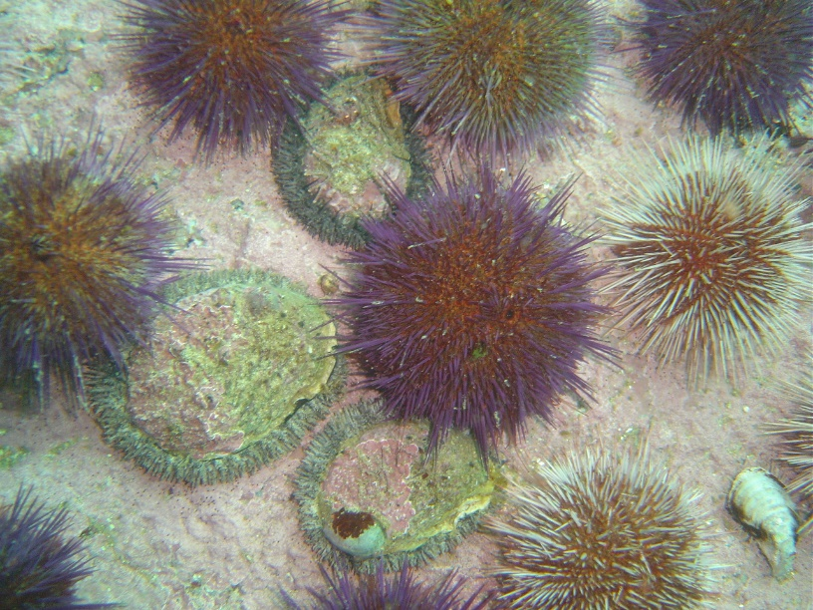For IMTA systems to succeed, both species being co-cultured should have commercial potential. However, the feasibility of the Cape sea urchin as an additional value-added product has not been investigated as yet. This project is exploring the feasibility of the Cape sea urchin, *Parechinus angulosus*, as a new market product for South Africa which has the potential to be co-cultured with South African abalone, *Haliotis midae*, through an IMTA system. Through the improvement of the culturing protocols for this urchin species, further value could be added to the co-culturing of sea urchins and juvenile abalone, increasing the sustainability of the abalone aquaculture industry and potentially, the Cape sea urchin may diversify the South African aquaculture market.

Figure 2: Image of juvenile abalone (*Haliotis midae*) sheltering beneath Cape sea urchins (*Parechinus angulosus*) in Simon’s Town, Cape Town, South Africa (Peter Southwood, 2005).

## Research aim and objectives

One of the major factors influencing the marketability of sea urchins is their gonad colour and texture (Shpigel et al., 2005). The effects of different temperatures and feeding regimes on the growth performance, optimal gonad colour and gonadal somatic index (GSI) of this species has not been assessed, this project aims to address these knowledge gaps. The spinal colour variation of the Cape sea urchin may potentially impact their gonad colour and thus, may add commercial interest to the species.

* + 1. **Research Aim**

The aim of the study is to assess the potential of the Cape sea urchin, *Parechinus angulosus*, as an additional value-added product within an IMTA system.

* + 1. **Research Objectives:**
       1. Assess somatic growth and gonad development of the Cape sea urchin held at different temperatures: ambient (at Sea Point DFFE mariculture laboratory on the Cape southwest coast) and warmed to 18°C.
       2. Assess the effects of different diets on somatic growth and gonad development of the Cape sea urchin held at different temperatures: the sea lettuce *Ulva lacinulata* (U), *Ecklonia maxima* kelp (K), 16U formulated feed (F), and a combination of the forementioned diets (U, K, F) rotated on a weekly basis to form a mixed diet (M).
       3. Evaluate gonad quality (colour, texture, firmness), under the above-mentioned temperatures and feeding regimes, to assess the feasibility of gonad enhancement and marketability of the Cape sea urchin.
       4. Assess feed conversion ratio, under the above-mentioned temperatures and feeding regimes, of the Cape sea urchin.
       5. Assess the effects of test colour on gonad colour.

# **Literature review**

## An overview of the seafood industry

- Examine current trends in the global seafood market.

- Discuss the challenges and opportunities faced by the seafood industry.

Scite AI:

The seafood industry is indeed a multifaceted sector that plays a crucial role in global food production and trade. It encompasses various aspects such as fisheries, aquaculture, processing, preservation, and distribution. The industry is characterized by a significant level of consolidation, with a few large companies controlling a substantial portion of the global catch and revenue (Blasiak et al., 2021). This consolidation has implications for market dynamics and sustainability efforts within the industry. Additionally, the seafood industry is a major source of employment, directly engaging millions of people and supporting the livelihoods of hundreds of millions more (Tveterås et al., 2012).

Traceability has emerged as a critical tool in addressing various challenges within the seafood industry, leading to initiatives by non-governmental organizations, companies, and government actors (Lewis & Boyle, 2017). These initiatives aim to improve the transparency and accountability of seafood supply chains, thereby enhancing sustainability and food safety. Furthermore, the emergence of Industry 4.0 technologies has led to advancements in seafood processing, preservation, and analytical techniques, contributing to improved efficiency and quality control in the industry (Hassoun et al., 2022).

The sustainability of the seafood industry is a growing concern, with efforts being made to address overexploitation of resources and unsustainable working conditions. As more capital flows into the industry, there is a need to ensure that investments prioritize sustainability and responsible practices (Jouffray et al., 2019). Moreover, the industry faces challenges related to the impact of the COVID-19 pandemic, including disruptions to supply chains and concerns about seafood safety and human health (Villasante et al., 2021; Rathod et al., 2022).

The seafood industry is also influenced by global trade dynamics, with key players such as China significantly shaping production, consumption, and trade patterns (Crona et al., 2020). Additionally, the industry is increasingly being scrutinized for its environmental footprint, with calls for a transition to more sustainable and plant-based dietary choices (Riverola et al., 2022). Overall, the seafood industry is at a crossroads, facing a range of challenges and opportunities that require concerted efforts from various stakeholders to ensure its long-term sustainability and resilience.

- Traditional seafood sources

- Provide an overview of commonly consumed seafood and their market status.

- Discuss the sustainability issues and concerns in traditional fisheries.

Scite AI:

The traditional sources of seafood have historically been fisheries, which have been the primary means of seafood production. However, due to the overexploitation of fish stocks, seafood production has progressively transitioned to aquaculture, which has experienced significant growth in recent decades (Schmidt et al., 2016). Aquaculture now accounts for nearly 50% of all seafood consumed globally, surpassing terrestrial livestock production and wild-capture fisheries (Bohnes & Laurent, 2018). This shift to aquaculture has been driven by the need for sustainable seafood production and the limitations posed by overfishing and unsustainable fish stocks (Schmidt et al., 2016).

Furthermore, the consumption of traditional fermented seafood products, such as jeotgal and sikhae in Korean cuisine, has been a longstanding practice for long-term storage and consumption (Kim et al., 2014). Additionally, the use of fishmeal as a traditional feed for farmed seafood, poultry, and pigs has been a historical practice in the industry (Fabris et al., 2020). Moreover, traditional dried seafood-based products are widely consumed in various cultures, such as in Thailand, due to their convenience and long shelf life (Soodsawaeng et al., 2023).

The coastal location of certain regions has provided ready access to seafood, making it one of the richest food sources for essential nutrients such as (n-3) fatty acids (Fialkowski et al., 2010). This has been particularly relevant for Pacific Northwest Tribal Nations, where seafood has been a significant part of the diet (Fialkowski et al., 2010).

In summary, the traditional sources of seafood have included fisheries, aquaculture, and the consumption of various traditional seafood products in different cultures. The shift towards aquaculture as a primary source of seafood production reflects the industry's response to the challenges of overfishing and the need for sustainable practices.

## Aquaculture’s contribution to seafood supply

(*How big is the seafood industry?)

The increasing demand for seafood products, coupled with the diminishing productivity of wild-caught marine fish stocks, mostly due to the overexploitation and illegal exploitation of fish stock, positions the aquaculture industry as a significant contributor to the global seafood supply (Granada et al. 2016) (Figure 1). Aquaculture production significantly supplements capture fisheries production (Longo et al., 2019) contributing 49.2 % to the global production of aquatic animals in 2020, but despite the great diversity in farmed aquatic species, only a small number of “staple” species dominate aquaculture production (FAO, 2022). Further development of the aquaculture industry is necessary to meet growing demand for fish products.

Aquaculture of fed aquatic animals continues to outpace that of non-fed aquatic animals making the aquaculture industry an important consumer of wild-caught marine fish stocks by using fishmeal in aquafeeds, raising concerns about the sustainability of the industry. Aquaculture effluent is another growing concern for the rapidly expanding industry. Both fresh- and saline water aquaculture require large amounts of water with good quality. Uneaten feed and waste products, result in the accumulation of suspended solids, otherwise known as particulate organic matter (POM) and dissolved organic substances (DOM), which contain compounds such as nitrogen and phosphorus, and possibly also other chemicals that are used to prevent diseases of aquatic species (Jegatheesan et al., 2011). This effluent water is discharged into the environment, which if untreated can be detrimental to the surrounding environmental and human health. Thus, intensive development of aquaculture has raised a range of environmental concerns such as effluent discharge, excessive use of resources and dependence on commercial feed (Granada et al., 2016) placing a spotlight on the need for research on sustainable aquaculture systems and practices.

1. A graph showing the growth of the company's sales

   Description automatically generated
2. Figure 1: World capture fisheries and aquaculture production excluding aquatic mammals, crocodiles, alligators, caimans, and algae. Data expressed in live weight equivalent. (FAO,2022)

## Diversification of the aquaculture industry

Why is diversification important?

IMTA: Integrated multi-trophic aquaculture (IMTA) is an advanced form of aquaculture considered a suitable approach to limit aquaculture nutrients and organic matter outputs through biomitigation (Granada et al., 2016). In IMTA systems, nutrients from uneaten feed and excreted waste from fed species become food for extractive species (FAO, 2022). Converting the waste products from one species into a valuable resource for another reduces the amount of nutrients released into the environment while enhancing overall productivity. The extractive species in IMTA systems are both traded as a commodity and used as a biofiltration system, which increases their value to the farm, this is especially important for extractive species with low commercial value or species which are new entrants to the market. The implementation of IMTA systems can increase the efficiency of aquaculture systems and contribute to the development of a sustainable aquaculture industry, particularly when species that are ecologically compatible are co-cultured (Kang et al. 2003; Kim et al. 2015). IMTA has the potential to reduce environmental impacts, increase profitability and diversify commercial production in a sustainable way.

IMTA in SA abalone industry: ***

SA Tripneustes research (what is the urchin product exactly, how does it compare?)

Tripneutes/Ulva potential

WW urchins work but most of SA coast is cold

## Echinoculture research and practices

- Summarize existing studies or observations regarding the taste, texture, and culinary potential of Parechinus angulosus.

- Discuss any unique nutritional benefits it might offer compared to traditional seafood.

* Sea urchin market analysis/summary
* Areas of controversy or need for improvement
* Does this project relate to any gaps within the industry?

Expectations/Previous work

* Has anyone done anything similar? What did they find?
* What are factors that have affected gonad quality/growth rate/feeding rate for other species?

The sea urchin industry is also associated with aquaculture, with efforts being made to sustainably cultivate sea urchins for commercial purposes (Rubilar & Cardozo, 2021). In the USA, sea urchin aquaculture is being considered in several states, including California, Oregon, Washington, Maine, Massachusetts, and New Hampshire (Nelson et al., 2010).

## Challenges and considerations

- Address potential challenges associated with harvesting, processing, and marketing Parechinus angulosus.

- Discuss any environmental or ethical considerations related to its exploitation.

## Project expectations

This project

* Motivation for the factors I am considering & methodology followed:
  + Feeds chosen: is it what they naturally eat? (e.g., *Ecklonia maxima* characterizes the environments usually populated by *P. angulosus*)
  + Temperatures chosen
  + How does my methodology compare with other studies?
* Project hypotheses

# **Materials and methods**

## Ethics statement

Wild *Parechinus angulosus* were collected in the intertidal and shallow subtidal on a rocky shore in front of the DFFE Marine Research Aquarium in Sea Point, Cape Town (33° 55' 6.492'' S, 18° 22' 52.572'' E). This site is not privately owned or protected in any way, according to South African legislation (SAFLII, 2019). This study did not include endangered or protected species. All experimental procedures on animals were in compliance with the welfare guidelines of the DFFE. Daily biosecurity checks were performed for the duration of the study according to the biosecurity standard of the DFFE.

## Sea urchin collection

The sea urchins (*Parechinus angulosus*) were collected from the rock pools in front of the Marine Research Aquarium in Sea Point in May 2023. A total of 650 individuals of an average size of 4cm diameter were collected and immediately transported to plastic tanks with a flow-through system er at the Marine Research Aquarium. Prior to the start of the experiment the urchins were starved for three weeks to reduce their gonad weight and ensure that all animals had a similar gonad state prior to the start of the trial. Thereafter, the urchins were stocked into oyster mesh baskets (L x W x D: 40 x 29 x 16 cm; mesh size: 6 mm) suspended in smaller plastic tanks (L x W x H: 42 x 36 x 30 cm) at 19 animals per basket (stocking density) and fed *Ecklonia maxima* for two weeks while they acclimatised to the experimental system. A similar size range of urchins (Table 1) were stocked in each basket across the various treatments to mitigate against growth rate differences due to different sized animals. *Parechinus angulosus* has a wide range of spinal colours (pink, light purple, dark purple, orange and red). Where possible, equal ratios of urchins with different test colours were selected for each basket.

Table 1. Initial size (test diameter in mm) and wet weight (g) of *P. angulosus* at the start of the trial

|  |  |  |  |  |
| --- | --- | --- | --- | --- |
| **Diet** | **Temperature** | **Treatment** | **Mean urchin test diameter (mm)**  **(mean ± se)** | **Mean urchin wet mass (g)**  **(mean ± se)** |
| formulated | ambient | fa | 32.91 ± 0.83 | 16.75 ± 0.77 |
| formulated | warm | fw | 35.61 ± 0.73 | 18.92 ± 0.75 |
| mixed | ambient | ma | 32.52 ± 0.85 | 15.00 ± 0.70 |
| mixed | warm | mw | 33.81 ± 0.90 | 16.91 ± 0.87 |
| ulva | ambient | ua | 33.71 ± 0.88 | 16.75 ± 0.83 |
| ulva | warm | uw | 33.80 ± 0.81 | 17.04 ± 0.79 |
| kelp | ambient | ka | 34.19 ± 0.96 | 17.83 ± 0.95 |
| kelp | warm | kw | 32.40 ± 0.72 | 15.70 ± 0.72 |

## Experimental setup

A flow-through experimental system was utilized for the trials, consisting of 32 rectangular plastic tanks (L x W x H: 42 x 36 x 30 cm). There were four tanks (replicates) for each treatment and each tank had a volume of 40 l; when accounting for the height of the outflow. Seawater for the ambient and the heated tanks was pumped from the kelp beds in front of the DFFE Marine Research Aquarium (MRA). Before entering the experimental systems, seawater passed through a drum filter and then a sand filter prior to entering a sump tank at the highest level of the MRA. For the ambient system, water from the sump was gravity fed into the experimental tanks at a rate of ~1000 L/min (~1.5 tank turnovers/hr). Conversely, for the heated system, water from the main sump at the MRA was gravity fed into two interconnected 2,500 L JoJo tanks where the water was constantly recirculated through a heat pump set at 19 oC before entering the experimental tanks, at a rate of ~ 1000 L/min (~1.5 tank turnovers/hr). This experimental system included two temperature treatments: ambient (A: ambient) incoming water and a consistent temperature (W: warm) of 18°C (temperature controlled using a heat pump).The exact temperature in the ambient and heated experimental tanks was continuously recorded at 30-minute intervals using a temperature probe (brand/model) and the average temperature over the entire experimental period was 15.36 ±0.009 oC and 18.88 ± 0.006 oC for the ambient and heated systems, respectively.

The aeration in the tanks was provided by one airstone per tank. Effluent water returned directly to the ocean through the main effluent pipe of the MRA. The density of animals and feed we use is so low it has minimal impact on the surrounding environment. You can state this if you wish, but probably not necessary.

The internal surfaces of tanks were manually cleaned of their sediments and fouling organisms twice a week, using a siphon and synthetic fibre brush.

Four feeding regimes were tested in quadruplicate: *Ulva lacinulata* (U), *Ecklonia maxima* kelp (K), a formulated feed containing 16% *Ulva* (F), as well as a rotation of the forementioned diets (U, K, F) on a weekly basis to form a mixed diet (M), resulting in a total of 16 tanks (320 sea urchins). All feeds will be administered ad libitum, to avoid overfeeding, the amount of feed added at the start of the experiment was calculated as a percentage of the total body weight within each tank (U: 8%, F: 1.8%, K: 10%). Kelp fronds were cut into small segments (L x W: width of kelp frond x 5 cm) to increase surface area of feed available.

Therefore, a total of 32 tanks were stocked with sea urchins, equating to 640 sea urchins for inclusion in the study.

The 8 treatments were randomly assigned to tanks in the following arrangement:

*Add schematic*

Table 1. Tank treatment allocation

(F: formulated feed, M: mixed diet, U: ulva, K: kelp, A: ambient, W: warm).

|  |  |  |  |
| --- | --- | --- | --- |
| FW 1 | MW 2 | FA 3 | MA 4 |
| MW 5 | UW 6 | KA 7 | UA 8 |
| UW 9 | KW 10 | KA 11 | FA 12 |
| FW 13 | MW 14 | UA 15 | MA 16 |
| UW 17 | KW 18 | FA 19 | KA 20 |
| KW 21 | UW 22 | MA 23 | FA 24 |
| MW 25 | FW 26 | UA 27 | UA 28 |
| KW 29 | FW 30 | MA 31 | KA 32 |

## Data collection

### *Survival rate, somatic growth and feed conversion ratio*

Somatic growth was measured in terms of urchin total wet weight (g) and diameter (cm) at six measurement timepoints (T0: initial, T1: 4 weeks, T2: 8 weeks, T3: 13 weeks, T4: 18 weeks, T5: 23 weeks) over the course of the study. At every timepoint all sea urchins were individually weighed and measured using standardised photographs taken with an iPhone 8. All images were processed using the “Urchin Vision” software developed by De Vos et al. (2023) and the average diameters and weights of animals in each tank were recorded.

Feed conversion ratios were measured for each tank by determining feed consumption over a 7-day period, divided by the corresponding wet weight increase over the 7 days using the following formulae:

$$FCR=\frac{Feed consumed}{Urchin wet weight gain}$$

All urchins were weighed at the start of the week (for week 0, 4, 8, 13, 18 and 23), these values were used for the somatic growth data. To allow the sea urchins to adapt to the treatments before feed consumption was measured, feed consumption measurements were recorded from week 8 onwards.

All urchins were measured again at the end of the week (for weeks 8, 13, 18 and 23), these values were used to calculate wet weight increase over the 7 days. The total feed consumed per tank over the 7 days was calculated as the difference between the feed introduced and the residual feed removed from the tank. The amount of feed added to the tank was weighed, in grams, at the start of the week.

Macroalgae tissues (Ulva and Ecklonia maxima) were still intact after 7 days when residual material was removed and therefore, no significant process of degradation and weight reduction within the experimental time was considered. These tissues were spun using a salad spinner to remove excess moisture before they were weighed. The formulated feed however, was significantly degraded, and the residual formulated feed in each tank was thus removed every 3 days and new formulated feed was weighed (g) and added for the experiment. The residual formulated feed was placed into foil weigh boats and dried to a constant weight in an oven at 60oC for 48 hours to remove excess moisture before being weighed. Feed consumption was calculated in milligrams of feed (dry weight) consumed per tank, per week. The feed consumption was then divided by the number of animals in the tank and by the number of days for the feed consumption experiment to calculate the average feed (dry weight in milligrams) consumed per animal, per day.

The somatic growth data collected in terms of weight (g) (Table no) and size (cm diameter) (Table no) was averaged per tank and used to calculate the specific growth rate (SGR). SGR (% growth/day) (Table no) of each treatment was calculated for five intervals (between each respective timepoint) using mean weight (g) and size (mm) measurements per timepoint per tank per treatment:

$$SGR=100*\frac{(ln⁡(\frac{l_{f}}{l_{i}}))}{t} CITATION Mul13 \backslash l 1033 (Mulvaney, et al., 2013)$$

Where mf = measurement final (g or cm); mi = measurement initial (g or cm); t = time (days) between final and initial measurements.

The intervals for the five specific growth rates calculated:

1. Week 4: week 0 - week 4 (t = 29 days)
2. Week 8: week 4 – week 8 (t = 29 days)
3. Week 13: week 8 – week 13 (t = 32 days)
4. Week 18: week 13 – week 18 (t = 36 days)
5. Week 23: week 18 – week 23 (t = 36 days)

### *Gonad quantity, quality and development*

Prior to dissection, the urchin was briefly placed in a mesh basket to drip dry, draining excess seawater from the sea urchin body. Whole animal wet weight (g) was recorded after which they were dissected in half using dissection scissors and tweezers to remove the gonad segments from the test. All other visceral tissues attached to the gonad were cleaned off before quantifying the total gonad wet weight (g) and calculating the gonadal somatic index (GSI) (%) using the following formulae:

$$GSI (\%) = \frac{gonad wet weight (g)}{whole sea urchin wet weight (g)}* 100$$

Gonad quality was measured in terms of gonad colour, which was measured using a hand-held fibre-optic spectrophotometer (Lovibond® LC 100 spectrocolorimeter). The L*a*b* colour space is used to quantifiably define colours (CIE reference) within the food industry (Suckling reference) and for sea urchin gonads (Suckling references). Three replicate measurements of CIE L* (intensity or lightness), a* (hue or redness) and b* (chroma or yellowness) were recorded from each sampled gonad (Onomu et al., 2020).

One gonad segment per urchin was kept for gonad development assessment, through histological analysis, to ascertain the gametogenic state of the urchin. The gonad segment was kept in a 50ml test tube and fixed in Davidson’s fixative (formula) for a period of 48 hours. After 48 hr of immersion in the fixative, the samples were transferred to 70% ethanol for storage prior to paraffin histology (Bucke, 1989). Gonad maturity was analysed according to the method described by Cyrus, Bolton, and Macey (2015). Gonads were categorized into one of 6 different maturity stages of echinoid gametogenesis, namely (1) recovery, (2) growing, (3) premature, (4) mature, (5) partly spawned, and (6) spent (Vaïtilingon, Rasolofonirina, & Jangoux, 2005) (Table 2). Gonads having little or no gametogenic activity were considered as high-quality, that is gonads in the growing or premature stages (Onomu et al., 2020).

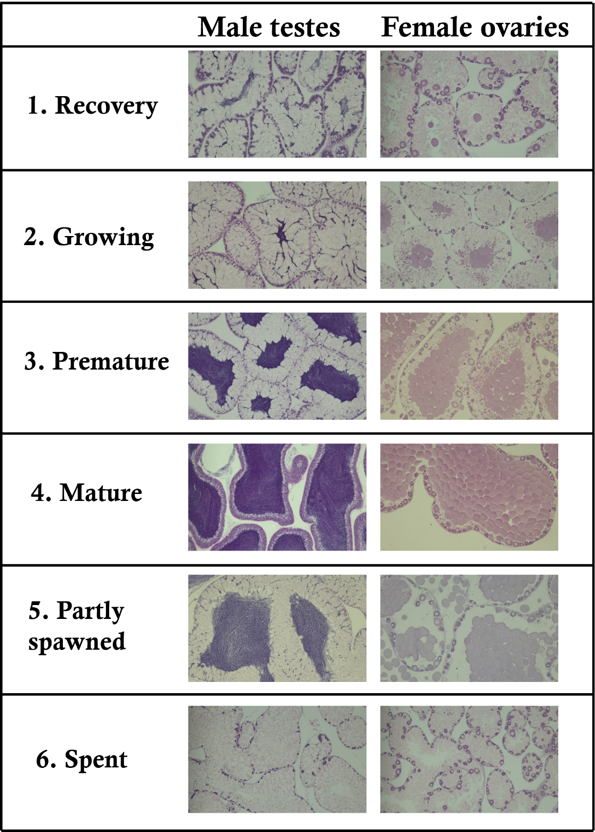

Figure 2: Gonad histology of *P. angulosus* male testes and female ovaries depicting the respective gonad maturity stages ((1) recovery, (2) growing, (3) premature, (4) mature, (5) partly spawned, and (6) spent)

## Statistical Analyses

Data was stored in Microsoft Excel (V16.0.17126.20126) and data analyses and plots were performed using R statistical software (R Core Team, 2023).

The data were tested for normality (Shapiro-Wilk) (Shapiro & Wilk, 1965) and homogeneity of variance (Levene’s test using *car* package; Fox & Weisberg, 2019) (Levene, 1960) and if these assumptions were met then a one-way analysis of variance (ANOVA) (Fisher, 1992) was conducted to assess the effects of the dietary and temperature factors {and the combination thereof (treatment)??} on somatic growth rate, gonad colour (CIE L*a*b values), gonad development and gonad index (GSI). Where significant results were found between diet or treatment (multiple independent samples), Tukey’s (Keselman & Rogan, 1977) post-hoc pairwise comparisons were conducted to determine diet or treatment differences.

If data failed to meet the ANOVA assumption of normality following either a log or square root transformation, then a nonparametric Kruskal Wallis test (Kruskal & Wallis, 1952) was conducted (survival rate, if possible, state which datasets). Where significant differences occurred, Dunn’s (Dinno, 2015) post-hoc comparisons were conducted to determine treatment differences (using the *dunn.test* package). Due to multiple testing, a Bonferroni correction was applied to reduce the type I error rate.

If data had a normal distribution but failed to meet the assumption of homogeneity, then a Welch ANOVA (Welch, 1951) was conducted. Where significant differences occurred, Games-Howell (Games & Howell, 1976) post-hoc comparisons were conducted to determine treatment differences (using the *rstatix* package).

Should I be doing t-tests for temperature differences instead??

# **Results**

## Survival

Diet had a significant effect on survival rate (%) (Kruskal-Wallis, p < 0.001) within the first nine weeks of the experiment (Figure 4). The kelp dietary treatment had a significantly lower (Dunn – Bonferroni test, p < 0.05) survival rate than all other dietary treatments in this period. Many urchins in the kelp dietary treatment group showed severe spine loss and were removed from the tanks for disease and water quality concerns (Appendix, Figure A1). Due to the consistently poor health (Appendix A2, morbidity graph) during the early stages of the experiment and concerns for the health of the animals, the kelp dietary treatment was suspended in week 9. Kelp dietary treatment urchins were ethically euthanized as per DFFE biosecurity regulation and kelp was removed from the mixed dietary treatment feeding regime. The mixed diet regime changed to *Ulva lacinulata* and a formulated feed containing 16% *Ulva* on a weekly basis from week 10 onwards. Eliminating the kelp dietary treatment increased the significance of the temperature treatment effect on survival rate (Kruskal-Wallis, p < 0.05). The warm temperature treatment group had a significantly higher survival rate than the ambient temperature treatment group overall (Dunn – Bonferroni test, p <0.05). (Sig differences over time between week 10 and 24?)

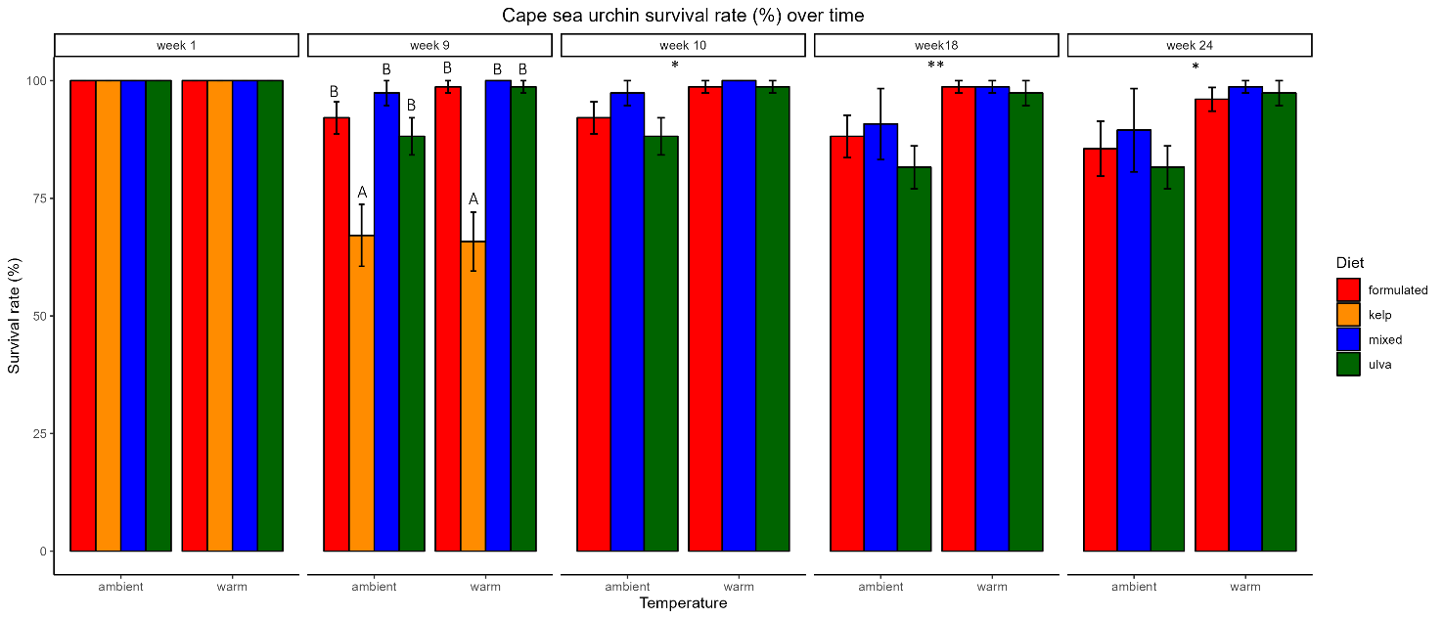

Figure 3: Mean (± SE) of survival rate (%) for the Cape sea urchin, *P. angulosus*, fed different diet treatments (formulated feed with 16% ulva, *Ecklonia maxima* kelp, *Ulva lacinulata*, and a combination of the forementioned to form a mixed diet) under different temperature conditions (ambient and warm). Letters above bars represent dietary treatment groups that are significantly different to each other based on Dunn’s test with Bonferroni correction. Stars above bars indicate the level of significant difference between temperature treatment groups (*:p<0.05, **: p<0.01, ***:p<0.001). No letters or stars indicate no significant differences.

## Somatic growth

Temperature had a variable effect on somatic growth. In week 4, the ambient temperature group…

Write it up!

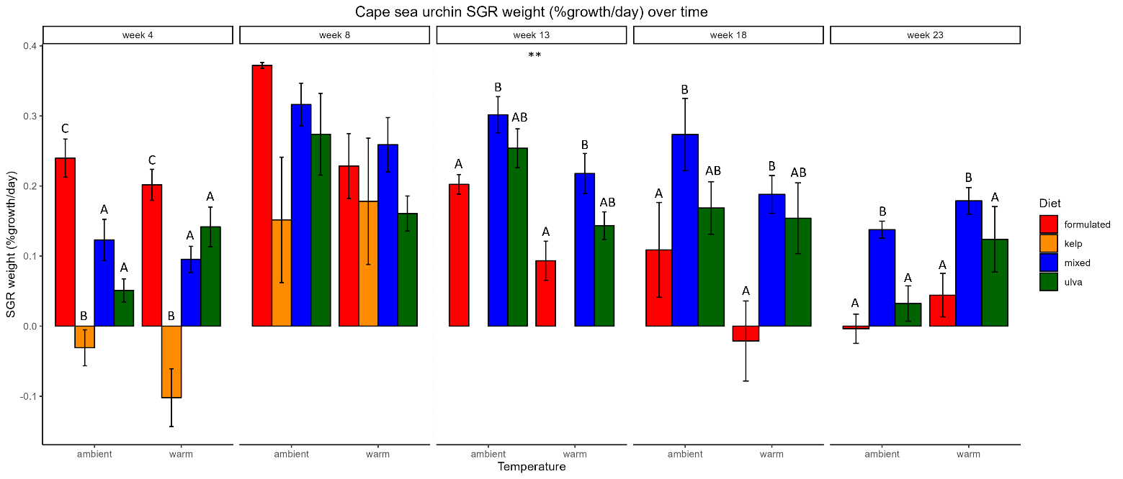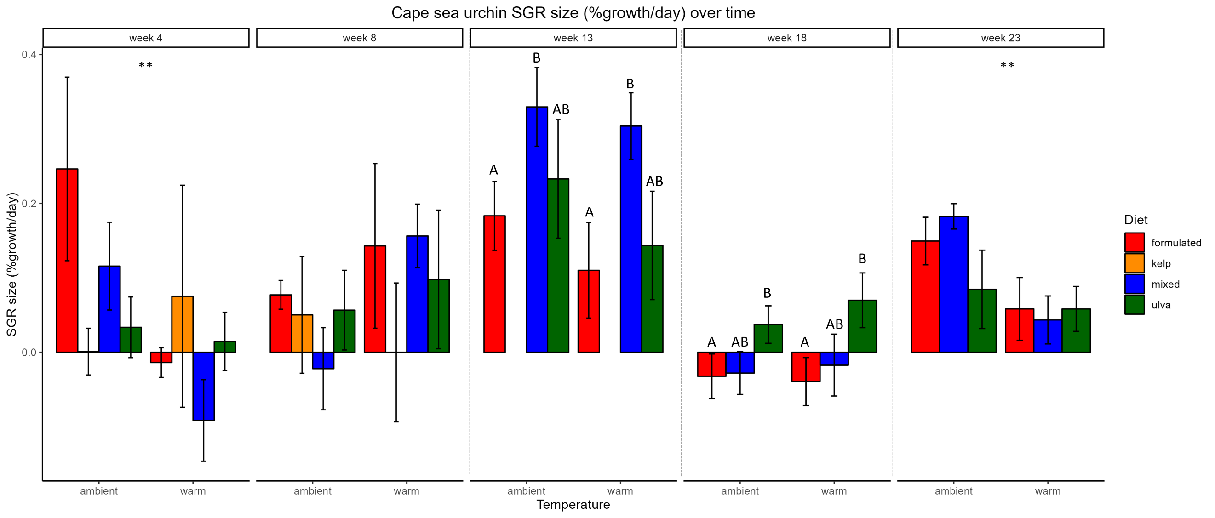

**A**

**B**

Figure 4: Mean (± SE) **A)** whole animal wet mass (g) and **B)** test diameter (mm) specific growth rate (SGR) (% growth day-1) for the Cape sea urchin, *P. angulosus*, fed different diet treatments (formulated feed with 16% ulva, *Ecklonia maxima* kelp, *Ulva lacinulata*, and a combination of the forementioned to form a mixed diet) under different temperature conditions (ambient and warm). Letters above bars represent dietary treatment groups that are significantly different to each other based on ANOVA (UPPERCASE), Kruskal-Wallis (lowercase) or Welch ANOVA (*lowercase italic*) followed by Tukey’s, Dunn’s with Bonferroni correction or Games-Howell post hoc pairwise comparison test respectively. Stars above bars indicate the level of significant difference between temperature treatment groups (*:p<0.05, **: p<0.01, ***:p<0.001). No letters or stars indicate no significant differences.

*Weight*

*Period A*

The SGR for period A (week 0 – week 4) was significantly different between treatments (df = 7, F = 18.32, p = 3.34e-08). The diet treatment factor strongly influenced these differences (df = 3, F = 39.201, p = 2.08e-09) while temperature did not (df = 1, F = 0.523, p = 0.48). The highest SGR (% growth/day) for period A was from the formulated diet (mean ± se) (0.22 ± 0.02 % growth/day) and the kelp diet the lowest SGR (-0.07 ±0.03 %growth/day). All diets had significantly different SGR’s in period A (Post Hoc Tukey) except for the mixed and ulva diets (p = 0.967).

*eriod D*

The SGR for period D (week 13 – week 18) was significantly different between treatments (df = 7, F = 9.96, p = 0.000423). The diet treatment factor strongly influenced these differences (df = 3, F = 11.64, p = 4.48e-05) while temperature did not (df = 1, F = 3.59 , p = 0.07). The highest SGR (% growth/day) for period D was from the mixed diet (mean ± se) (0.23 ± 0.03 % growth/day) and the formulated diet the lowest SGR (0.04±0.05 %growth/day). Only the mixed and formulated diets had significantly different SGR’s in period D (Post Hoc Tukey) (p = 0.002).Ulva had an SGR of 0.16 ± 0.03 % growth/day.

**Table 4.2.1** . Mean ± SE of survival rate (%) and specific growth rates (SGR) (% growth day-1) of wet weight (g) (SGRweight) and test diameter (mm) of Cape sea urchin, *P. angulosus*, fed one of four different dietary treatments: formulated (16U), *Ulva lacinulata* under different temperature conditions. Statistically significant differences are shown by different letters (letter format) based on ANOVA (UPPERCASE) or Kruskal-Wallis (lowercase) tests followed by a post hoc Tukey’s (t) or Dunn’s test (z) respectively. No letters indicate that there were no statistically significant differences between groups.

|  |  |  |  |  |
| --- | --- | --- | --- | --- |
| **Week** | **Diet** | **Temperature** | **Treatment** | **SGRdiam (%)**  **(mean ± se)** |
| 4 | formulated | ambient | fa | 0.25 ± 0.12 |
| 4 | formulated | warm | fw | -0.01 ± 0.02 |
| 4 | mixed | ambient | ma | 0.12 ± 0.06 |
| 4 | mixed | warm | mw | -0.09 ± 0.06 |
| 4 | ulva | ambient | ua | 0.03 ± 0.04 |
| 4 | ulva | warm | uw | 0.01 ± 0.04 |
| 4 | kelp | ambient | ka | 0.00 ± 0.03 |
| 4 | kelp | warm | kw | 0.08 ± 0.15 |
| 8 | formulated | ambient | fa | 0.08 ± 0.02 |
| 8 | formulated | warm | fw | 0.14 ± 0.11 |
| 8 | mixed | ambient | ma | -0.02 ± 0.06 |
| 8 | mixed | warm | mw | 0.16 ± 0.04 |
| 8 | ulva | ambient | ua | 0.06 ± 0.05 |
| 8 | ulva | warm | uw | 0.10 ± 0.09 |
| 8 | kelp | ambient | ka | 0.05 ± 0.08 |
| 8 | kelp | warm | kw | -0.00 ± 0.09 |
| 13 | formulated | ambient | fa | 0.18 ± 0.05 |
| 13 | formulated | warm | fw | 0.11 ± 0.06 |
| 13 | mixed | ambient | ma | 0.33 ± 0.05 |
| 13 | mixed | warm | mw | 0.30 ± 0.04 |
| 13 | ulva | ambient | ua | 0.23 ± 0.08 |
| 13 | ulva | warm | uw | 0.14 ± 0.07 |
| 18 | formulated | ambient | fa | -0.03 ± 0.03 |
| 18 | formulated | warm | fw | -0.04 ± 0.03 |
| 18 | mixed | ambient | ma | -0.03 ± 0.03 |
| 18 | mixed | warm | mw | -0.02 ± 0.04 |
| 18 | ulva | ambient | ua | 0.04 ± 0.03 |
| 18 | ulva | warm | uw | 0.07 ± 0.04 |
| 23 | formulated | ambient | fa | 0.15 ± 0.03 |
| 23 | formulated | warm | fw | 0.06 ± 0.04 |
| 23 | mixed | ambient | ma | 0.18 ± 0.02 |
| 23 | mixed | warm | mw | 0.04 ± 0.03 |
| 23 | ulva | ambient | ua | 0.08 ± 0.05 |
| 23 | ulva | warm | uw | 0.06 ± 0.03 |

## Gonad quantity and quality

Dietary treatment had a significant effect on GSI at every measurement timepoint. The formulated dietary treatment group had the highest gonadal somatic index (GSI) overall.

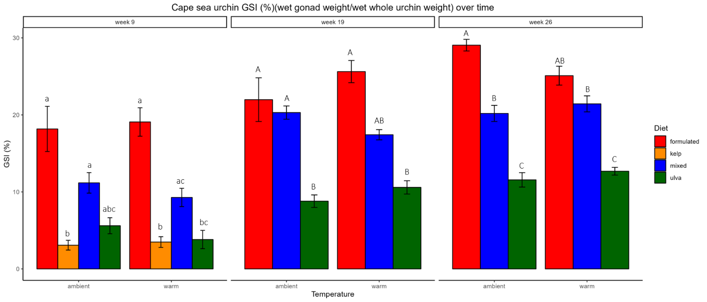

# **Discussion**

* Discuss most interesting results and possible reasons for unexpected results
* Did the project meet the project expectations & research objectives?
* Refer to other urchin work: how fast is their growth relative to other studies? How marketable is their gonad?

# **Conclusion**

* Is this feasible?
* What are the potential challenges?
* What were the research limitations?
* What are the opportunities for future research?

# **References**

Britz P. J., Hecht T., Mangold S., 1997 Effect of temperature on growth, feed consumption and nutritional indices of *Haliotis midae* fed a formulated diet. Aquaculture 152: 191–203.

Britz P.,Venter S., 2016. Aquaculture Review: South Africa. World Aquaculture: 20-28.

Bucke D., 1989. Histology. In B. Austin & D. A. Austin (Eds.), Methods for the microbiological examination of fish and shellfish (pp. 69–97). Chichester: Ellis Horwood.

C.I.E., 1931. Comission internationale de l’Eclairage: Proceedings 8th session. Cambridge, England, 19 to 29 September 1931 (Paris, France: Bureau Central de la C.I.E.).

Day E., Branch G. M., 2000 Relationships between recruits of abalone *Haliotis midae*, encrusting corallines and the sea urchin *Parechinus angulosus*. South African Journal of Marine Science: 137–144.

Day E., Branch G. M., 2002a Influences of the sea urchin *Parechinus angulosus* (Leske) on the feeding behaviour and activity rhythms of juveniles of the South African abalone *Haliotis midae* Linn. Journal of Experimental Marine Biology and Ecology 276: 1–17.

Day E., Branch G. M., 2002b. Effects of sea urchins (*Parechinus angulosus*) on recruits and juveniles of abalone (*Haliotis midae*). Ecological Monographs 72: 133–149.

De Vos B. C., Cyrus M. D., Macey B. M., Batik T., Bolton J. J., 2023. Combining computer vision and standardised protocols for improved measurement of live sea urchins for research and industry. Aquaculture, Fish and Fisheries. <https://doi.org/10.1002/aff2.137>

FAO, 2022. The State of World Fisheries and Aquaculture 2022. Towards Blue Transformation. Rome, FAO. <https://doi.org/10.4060/cc0461en>

Fox J., Weisberg S. 2019. An R Companion to Applied Regression. Third edition. Sage, Thousand Oaks CA. <https://socialsciences.mcmaster.ca/jfox/Books/Companion/>

Fricke A. H., 1980. Aspects of Population Structure of *Parechinus Angulosus* (Leske), Around the Cape Peninsula. South African Journal of Zoology 15: 177–185.

Granada L., Sousa N., Lopes S., Lemos M. F. L., 2016 Is integrated multitrophic aquaculture the solution to the sectors’ major challenges? – a review. Reviews in Aquaculture 8: 283–300.

Kang K. H., Kwon J. Y., Kim Y. M., 2003 A beneficial co-culture : charm abalone *Haliotis discus hannai* and sea cucumber *Stichopus japonicus*. Aquaculture 216: 87–93.

Kim T., Yoon H.S., Shin S., Oh M.H., Kwon I., Lee J., Choi S. D., Jeong K. S., 2015 Physical and biological evaluation of co-culture cage systems for grow-out of juvenile abalone, *Haliotis discus hannai*, with juvenile sea cucumber, *Apostichopus japonicus* (Selenka), with CFD analysis and indoor seawater tanks. Aquaculture 447: 86–101.

Mayfield S., Branch G. M., Cockcroft A. C., 2000. Relationships among diet, growth rate, and food availability for the South African rock lobster, *Jasus lalandii* (Decapoda, Palinuridea). Crustaceana, pp.815-834.

Nepgen C. S., 1982. Diet of predatory and reef fish in False Bay and possible effects of pelagic purse-seining on their food supply. Fisheries bulletin: Contributions to oceanography and fisheries biology-Republic of South Africa, Dept. of Agriculture and Fisheries.

Onomu A. J., Vine N. G., Cyrus M. D., Macey B. M., Bolton J. J., 2020. The effect of fresh seaweed and a formulated diet supplemented with seaweed on the growth and gonad quality of the collector sea urchin *Tripneustes gratilla*, under farm conditions, Aquaculture Research, 51(10): 4087–4102. <https://doi.org/10.1111/are.14752>

R Core Team. 2023. R: A Language and Environment for Statistical Computing. R Foundation for Statistical Computing, Vienna, Austria. <https://www.R-project.org/> .

Sonu, S.C., 2017. Sea urchin supply, demand, and market of Japan. *Silver Spring: US Dept Commer. NOAA NMFS West Coast Reg*. <https://www.st.nmfs.noaa.gov/Assets/commercial/market-news/00-Sea-urchin-Reports-Final-Nov-8-2018-2019.pdf> (Accessed: 10 January 2024)

South African Legal Information Institute (SAFLII). 2019. South Africa: Consolidated Regulations - Declaration of Areas as Marine Protected Areas. Available at: <https://www.saflii.org/za/legis/consol_reg/doaampa357/> (Accessed: 16 November 2023).

Shpigel, M., McBride, S. C., Marciano, S., Ron, S. and Ben-Amotz, A., 2005. Improving gonad colour and somatic index in the European sea urchin *Paracentrotus lividus*. Aquaculture, 245(1-4), pp.101-109.

Smith, C. D., 1999. Population biology and ecology of octopuses in the Southwestern Cape: a study towards the establishment of a small-scale octopus fishery (Master's thesis, University of Cape Town).

# **Appendix**

## Supplementary figures

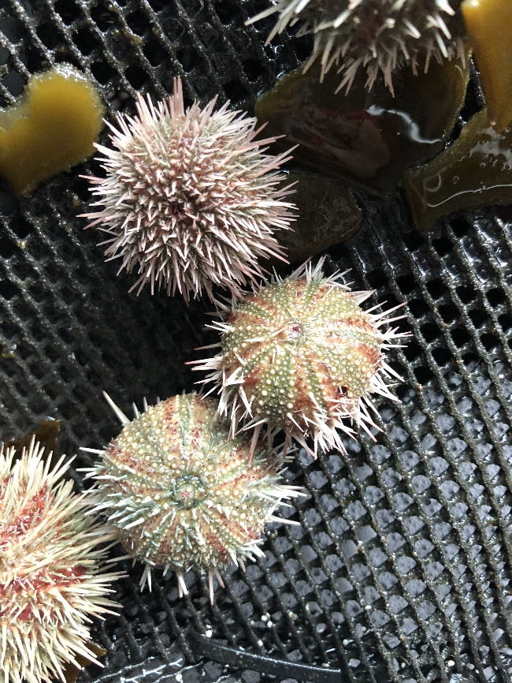

Figure A1: Image of *P.angulosus* in kelp dietary treatment group taken in week 2 of the experiment.

Maybe a bar graph with morbidities?

## Supplementary statistical tables

### Survival rate

Table A1.1. Kruskal-Wallis (H-values) test statistic for survival rate of *P.angulosus* fed one of four dietary treatments (formulated, *Ecklonia maxima*, mixed, or *Ulva lacinulata*) under one of two temperature treatments (ambient ~11 or warm ~15). Statistical significance is indicated as *: p<0.05, **: p<0.01, ***: p<0.001.

|  |  |  |
| --- | --- | --- |
| Week | Temperature | Diet |
| 9 (n=32) | H = 2.01 | H = 20.33 *** |
| 10 (n=24) | H = 5.76 * | H = 3.12 |
| 18 (n=24) | H = 7.77 ** | H = 1.40 |
| 24 (n=24) | H = 6.25 * | H = 1.52 |

Table A2.2. Mean ± SE for survival rate (%) of *P.angulosus* fed one of four dietary treatments (formulated, *Ecklonia maxima*, mixed, or *Ulva lacinulata*) under one of two temperature treatments (ambient ~11 or warm ~15). Statistically significant differences are shown by different letters based on Kruskal-Wallis test followed by a post hoc Dunn’s test pairwise comparisons. No letters indicate that there were no significant differences.

|  |  |  |  |  |  |  |  |  |
| --- | --- | --- | --- | --- | --- | --- | --- | --- |
| Temperature | Ambient | | | | Warm | | | |
| Diet | F | K | M | U | F | K | M | U |
| Week |  |  |  |  |  |  |  |  |
| 9 |  |  |  |  |  |  |  |  |
| 10 |  |  |  |  |  |  |  |  |
| 18 |  |  |  |  |  |  |  |  |
| 24 |  |  |  |  |  |  |  |  |

### Somatic growth

Table A2.1. ANOVA (F-values), Kruskal-Wallis (H-values) or Welch ANOVA (*F-values)* test statistics for specific growth rate (SGR) (% growth per day) of total wet weight (g) (SGR weight­) and test diameter (mm) (SGR size) for *P.angulosus* fed one of four dietary treatments (formulated, *Ecklonia maxima*, mixed, or *Ulva lacinulata*) under one of two temperature treatments (ambient ~11 or warm ~15). Statistical significance is indicated as *: p<0.05, **: p<0.01, ***: p<0.001.

|  |  |  |  |  |
| --- | --- | --- | --- | --- |
|  | SGR weight |  | SGR size |  |
| Week | Temperature | Diet | Temperature | Diet |
| 4 (n=32) | F = 0.07 | F = 30.95 *** | H = 6.76 ** | H = 2.24 |
| 8 (n=32) | *F =2.91* | *F =1.97* | F = 1.36 | F = 0.45 |
| 13 (n=24) | F = 14.30 ** | F = 5.00 * | F = 1.29 | F = 4.40 * |
| 18 (n = 24) | F = 2.29 | F = 6.49 ** | F = 0.17 | F = 4.88 * |
| 23 (n=24) | F = 3.51 | F = 9.91 *** | F = 8.46 ** | F = 0.54 |

Table A2.2. Mean ± SE for specific growth rate (SGR) (% growth per day) of total wet weight (g) for *P.angulosus* fed one of four dietary treatments (formulated, *Ecklonia maxima*, mixed, or *Ulva lacinulata*) under one of two temperature treatments (ambient ~11 or warm ~15). Statistically significant differences are shown by different letters based on ANOVA or Welch ANOVA tests followed by a post hoc Tukey or Games-Howell pairwise comparisons respectively. No letters indicate that there were no significant differences.

|  |  |  |  |  |  |  |  |  |
| --- | --- | --- | --- | --- | --- | --- | --- | --- |
| Temperature | Ambient | | | | Warm | | | |
| Diet | F | K | M | U | F | K | M | U |
| Week |  |  |  |  |  |  |  |  |
| 4 | 0.24 ± 0.03 c | -0.03 ± 0.03 b | 0.12 ± 0.03 a | 0.05 ± 0.02 a | 0.20 ± 0.02 c | -0.10 ± 0.04 b | 0.10 ± 0.04 a | 0.14 ± 0.03 a |
| 8 | 0.37 ± 0.00 | 0.15 ± 0.09 | 0.32 ± 0.03 | 0.27 ± 0.06 | 0.23 ± 0.05 | 0.18 ± 0.09 | 0.26 ± 0.04 | 0.16 ± 0.03 |
| 13 | 0.20 ± 0.01 a | - | 0.30 ± 0.03 b | 0.25 ± 0.03 ab | 0.09 ± 0.03 a | - | 0.22 ± 0.03 b | 0.14 ± 0.02 ab |
| 18 | 0.11 ± 0.07 a | - | 0.27 ± 0.05 b | 0.17 ± 0.04 ab | -0.02 ± 0.06 a | - | 0.19 ± 0.03 b | 0.15 ± 0.05 ab |
| 23 | -0.00 ± 0.02 a | - | 0.14 ± 0.01 b | 0.03 ± 0.03 a | 0.04 ± 0.03 a | - | 0.18 ± 0.02 b | 0.12 ± 0.05 a |